COSC 360
Lab 3 – Creating Layouts with CSS

Information:
Using the provided HTML file and images, correctly style the page as shown in the diagram. The spacing does not have to be exact but should approximate the layout of the page. The page is a layout design of a website with placeholder code.
Do not change the HTML. You will need to inspect the HTML code to determine the correct class values for different elements. Only your submitted stylesheet will be graded.

Instructions:
While an exact match is not required, attempt to reproduce as close as possible noting the marking rubric.
- Download the started folder for lab3 from Canvas.
- View the provided HTML5 code and images. Do not change the directory structure. Examine the lab3.html file to understand how specific elements have been identified.
- Create a new stylesheet called lab3.css and place it relative to your html file as css/lab3.css.
- Add styles to lab3.css using the class names provided in lab3.html to match the image
- You will have reusable class names that apply same style to different sections (e.g .section, .container)
- For best effects set your web browser screen to 1440px in responsive mode
- Start by applying default styles to the page using the styles below
*,
*::before,
*::after {
margin: 0;
padding: 0;
box-sizing: border-box;
}

html,
body {
font-family: sans-serif;
font-weight: normal;
scroll-behavior: smooth;
background: #e0e3e6;
font-size: 10px;
}

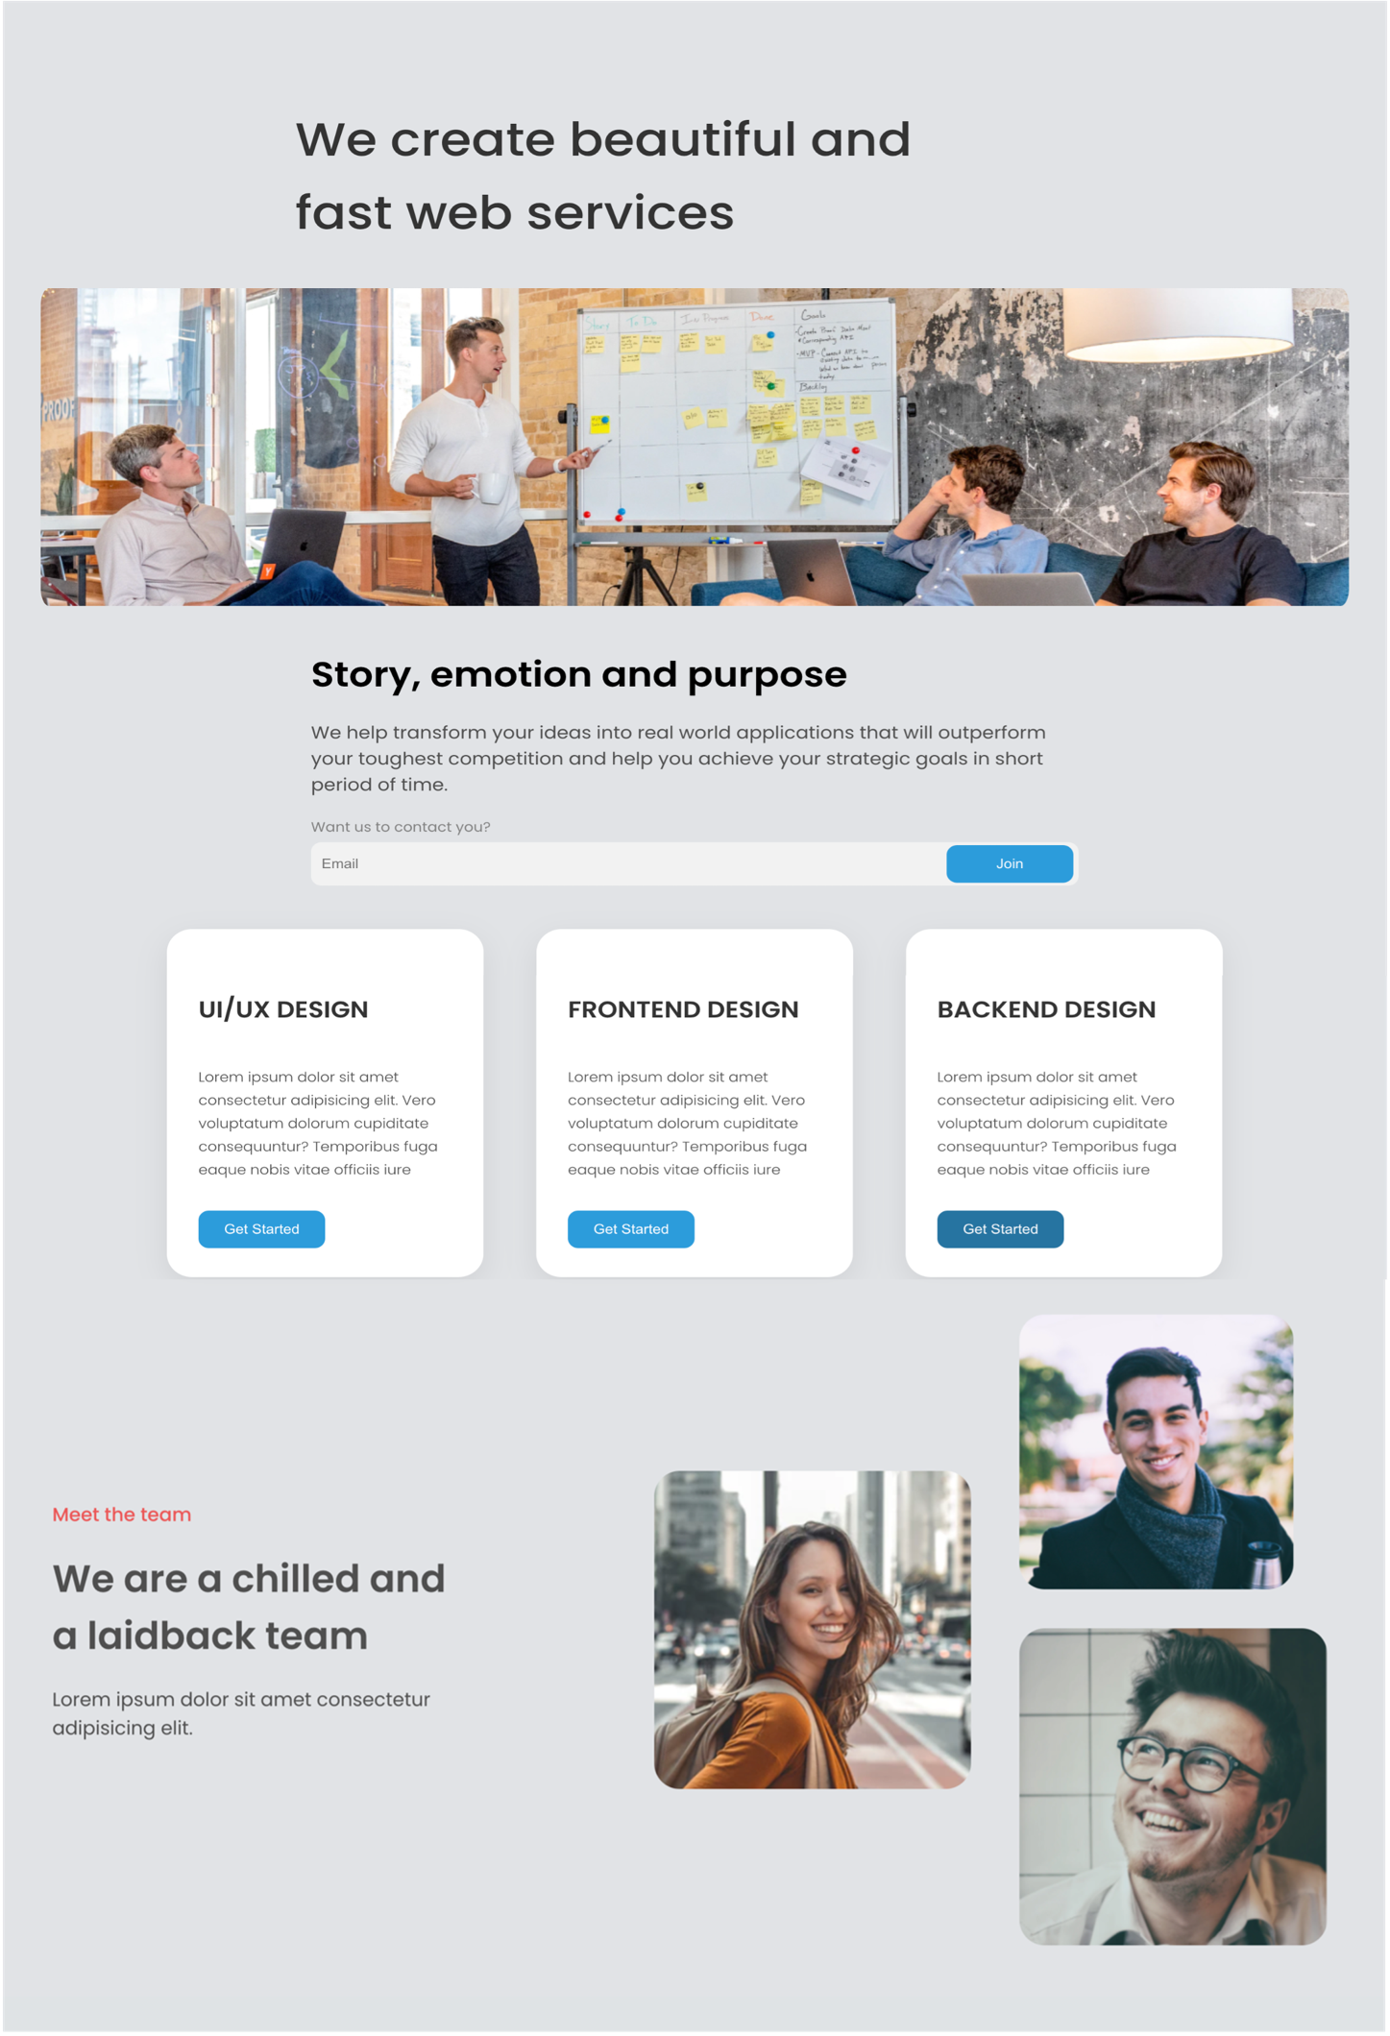
Item 12
Item 11
Item 9
Item 8
Item 10
Item 7
Item 6
Item 5
Item 4
Item 2 & 3
(reusable container & section)
Item 1 (layout)
- Item 1 - Main element with class “layout” should have max width of 1440px and padding of 2% all around. It should be centered on the page (tip: use horizontal margin “auto” to center it)
- Item 2 – a container class that surrounds different container elements.
  - top and bottom margin - 40px
  - centered on page (using margin)
  - vertical padding - 0
  - horizontal padding – 20px
  - max-width 767px
- Item 3 – a section class that surrounds sections
  - top and bottom margin - 40px
  - vertical padding 0
  - horizontal padding -5px
- Item 4 – main-heading class
  - Font weight -500
  - Max-width – 20 characters
  - Top margin – 80px
  - Bottom margin – 20px
  - No horizontal margin
  - Color - #333333
- Item 5 – heroImage class
  - Top margin – 20px
  - Border radius – 18px
  - Horizontal padding 10px
  - Use css to ensure image takes the full containing page width (max of 767px)
- Item 6 – caption class and copy class
  - Caption color – black
  - Copy color - #4f4f4f
- Item 7 - form class
  - Form should take full containing page width
  - Label – font-size 1.4rem, line-height-2.1rem color- #828282
  - Input – border radius 10px, height -45px , background color - #f2f2f2
  - Button- form button should float on the input, as shown in image (use css)
- Item 8 & 9 – Button
  - All buttons have same dimension ( form button, and card button)
  - Width – 120px
  - Vertical Padding – 9px
  - Horizontal padding – 20px
  - Background color - #2d9cdb
  - Item 9 On hover background of button should change to #2574a1
  - Use pointer cursor for hover
- Item 10 – card section
  - Use css flexbox to arrange cards as shown
  - Card dimensions are same
    - Padding -3rem
    - Background – white
    - shadow - 0px 10px 30px rgba(51, 51, 51, 0.1)
    - Border -radius -24px
    - Max-width 300px
    - Heading text using same font size as h3 and is uppercase
- Item 11 – team section
  - Use css flexbox to arrange the section as shown in image
  - Section should have horizontal padding 20px
  - “meet the team” text is #eb5757 and font-weight 500
  - Caption is #333333
  - metatext - #4f4f4f and vertical margin 20px
- Item 12 – team section images
  - Use css to arrage images. (you can use flexbox, grid, etc)
  - Do not use css float
  - class teamImage has max width 45%
  - Image items have border radius 24px
Tips:
- Use height of team image section is 50vw (limits the height based on the page width)
- Consider using flex-direction column and wrap-reverse to achieve the layout in the image

Submit your Lab-3 folder file on Canvas.

